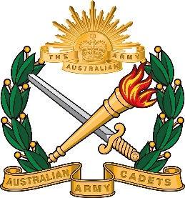 | 2nd New South Wales Australian Army Cadet Brigade  BAULKHAM HILLS HIGH SCHOOL CADET UNIT  419A Windsor Road Baulkham Hills NSW 2153  Ph: 9639 8699 Fax: 9639 4999  0409 604 901

3/2021

20 February 2021

Clothing Issue Day

Dear Parents / Guardians.

Date: Saturday, 06 MAR 21
Time: 0830 to 1230 (8:30 to 12:30pm)
Location: School TLC
Clothing: school sports uniform

Before you receive your uniform please make sure that you have completed the following.

- Have a cadet net account.

- Fees paid for the year.

- Filled in your clothing form.

The cadets will receive the basic uniform for cadets required for weekly parades, ceremony and bivouac.
You may not receive all the uniform on the day due to some shortages with the certain items.

All uniforms issued to the cadets are on loan and will be returned upon leaving cadets.

If you are not able to attend the day you will receive your uniform on the following Thursday.

C. Charlton
Captain (AAC)
Officer Commanding
0409 604 901

